Title of the paper
Name SURNAME ª, Name SURNAME ^{b}
ª Department of Economics, Faculty of Economics, University of Economics, Street 71, City, Country.
^{b} Department of Economics, Faculty of Economics, University of Business, Street 71, City, Country.
Abstract
The text of the abstract including the topic, aim, structure and main results. The text of the abstract including the topic, aim, structure and main results. The text of the abstract including the topic, aim, structure and main results. The text of the abstract including the topic, aim, structure and main results. The text of the abstract including the topic, aim, structure and main results. The text of the abstract including the topic, aim, structure and main results. The text of the abstract including the topic, aim, structure and main results. The text of the abstract including the topic, aim, structure and main results. The text of the abstract including the topic, aim, structure and main results. The text of the abstract including the topic, aim, structure and main results. The text of the abstract including the topic, aim, structure and main results. The text of the abstract including the topic, aim, structure and main results.

Keywords
Three to five keywords separated by comma, three to five keywords separated by comma.
JEL Classification: Two to four JEL codes
Title of the paper
Name SURNAME, Name SURNAME

- Introduction
[The purpose of the Introduction is to introduce the topic in a general way and introduce a particular problem to be analysed in the current paper, including relevant sources of literature that should stress the importance of the problem; the procedure should be also apparent.
After reading introduction, the following should be clear:
- Importance of the analysed problem,
- State of the art of the knowledge, ie what is already known and which questions should be answered or solution to which problems should be found.
- It should imply the aim of the paper as a result of the need to extend the knowledge about specific problem.
- Brief description of the paper procedure should be included as well.]
Text.
Text.
- Heading
Text.
Text.
  - Heading
Text.
Text.
  - Heading
Text.
Text.
Heading
Text.
Text.
- Heading
Text.
Text.
  - Heading
Text.
Text.
$B\left(t,T\right)=\text{NH}\text{exp}\left(−r_{d}τ\right),$ (1)
where $B\left(t,T\right)$ is …,
- text,
- ...
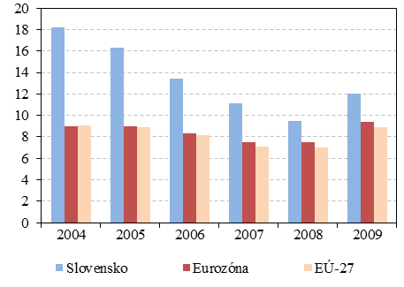
Figure 1–1 Title
Table 1–1 Title
- Conclusion
Text.
Text.
References
prokop, l., medvec, z., zmeškal, Z. (2009). Problematika oceňování nedodané energie v průmyslu. Ostrava: VŠB-TU Ostrava. [Monograph]
EMBRECHTS, P., MCNEIL, A., STRAUMANN, D. (2002). Correlation and dependence in risk management: Properties and pitfalls. In: Dempster, M.A.H. (ed.): Risk Management: Value at Risk and Beyond. Cambridge: Cambridge University Press, 176–223. [Chapter in Book]
BARTAM, S. M. (2007). Corporate cash flow and stock price exposures to foreign exchange rate risk, Journal of Corporate Finance 13: 981–994. [Paper in Journal]
DLUHOŠOVÁ, D. (2003). Performance analysis of the transitive economy companies and industries. In: Business Economics, Management and Marketing. Athens: Athens institute for education and research, 205–213. [Paper in Proceedings of Conference]
GIROUARD, N., ANDRÉ, C. (2005). Measuring cyclically-adjusted budget balances for OECD countries. OECD Economics Department Working Papers, No. 434: 1–42. Paris: OECD. [Working Papers]
Additional sources
BRYDEN, J. (2002). Rural Development Indicators and Diversity in the European Union. [Online], accessed at 20. 6. 2015. Available from: <http://srdc.msstate. edu/measuring/bryden.pdf>. [web sources, law, …]

Appendix

…
name@email.eu (corresponding author) Project acknowledgement. Project acknowledgement. Project acknowledgement. Project acknowledgement. Project acknowledgement. Project acknowledgement. Project acknowledgement. Project acknowledgement.

